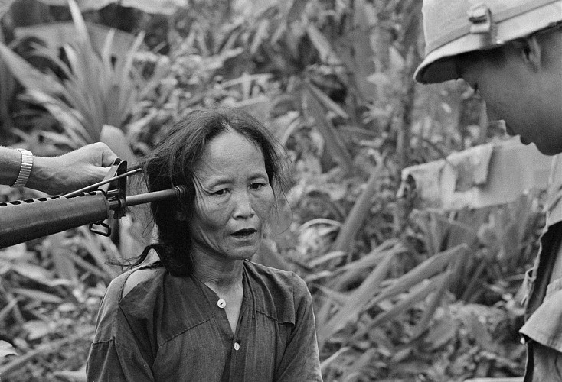

The Vietnam War was a conflict that occurred in Vietnam, Laos, and Cambodia from 1 November 1955 to the fall of Saigon on 30 April 1975, with U.S. involvement ending in 1973. This makes it the longest war of the 20th century. Its second particularity is that it is the first war to have been broadcast on television and in the media.

This war began with a violent opposition between North Vietnam, which is communist, and South Vietnam, which is not. The United States decided to send the American army in 1963 to prevent the Vietcong from invading the South. They were worried about the consequences of the dominoes: if the country fell into communism, so would its neighbours. Moreover It was very difficult for young teenagers who received a temporary card to go to Vietnam to fight. Many of them disapproved of this war and did not want to be part of it

I chose this image because it shows the violence of war. Here a young woman with a gun pointed violently at her head. We can see that the civilians were also hit, however he was not able to fight back, as in this image, the woman doesn’t fight, doesn’t defend herself, her gaze is fixed in the distance waiting for death.

This image belongs to the notion of place and form of power because it describes and reveals the violence of war to all, it shows the superior power of armies over civilians. Moreover, this war is a place and form of power because it shows the opposition of force between armies, and between governments.